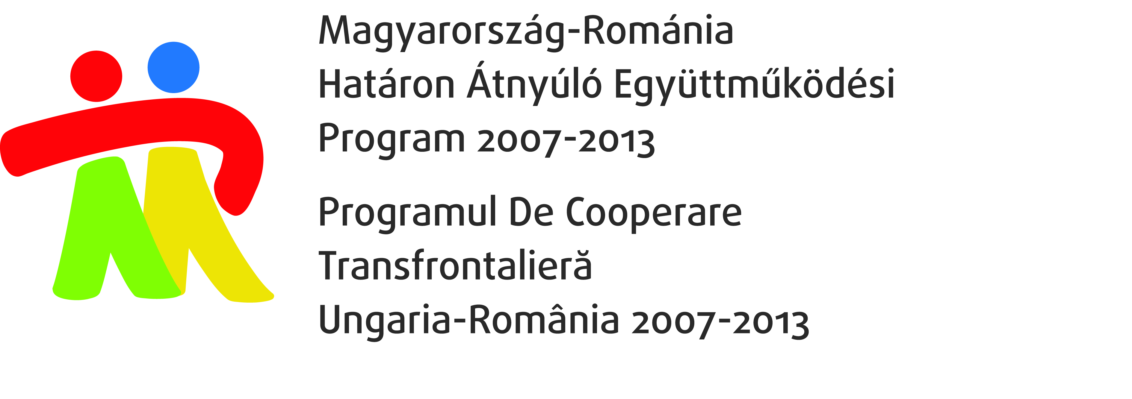

Invitation

The North Great Plain Regional Labour Centre (ÉARMK), AJOFM Bihor and AJOFM Satu Mare kindly invite you

to the opening conference of the project

„Hungarian – Romanian integrative cooperation on the labour market in the borderline region” (HUROJOB)
HURO/0801/051

Date: 30th June, 2010

Place: Kölcsey Conference Center, Hunyadi str. 1-3. Debrecen

The topic of the conference is the planned cooperation between the Hungarian and Romanian employment centres in both sides of the border which will be implemented in the framework of the above mentioned project.

Programme:

9.30-10.00 Registration

10.00-10.05 Welcome - Miskó Istvánné General Director, ÉARMK

10.05-10.30 Situation of the labour market in the region Észak-Alföld and activities of the
North Great Plain Regional Labour Centre – Miskó Istvánné General Director, ÉARMK

10.30-10.55 Activities of AJOFM Bihor and the characteristics of the labour market in Bihor county
– Dorel Draghici Director, AJOFM Bihor

10.55-11.20 Activities of AJOFM Satu Mare and the characteristics of the labour market in Satu
Mare county county Gheorghe Tilibasa Director, AJOFM Satu Mare

11.20-12:00 Presentation of the project Hungarian – Romanian integrative cooperation on the labour market in the borderline region – Feld Andrea projekt manager, ÉARMK

12.00-13.30 Lunch

The participation at the conference is free of charge, however, registration is required. Please fill out the attached application form and send it by fax to ++36/52/513-056 or by e-mail to felda@lab.hu till 25th June 2010.

