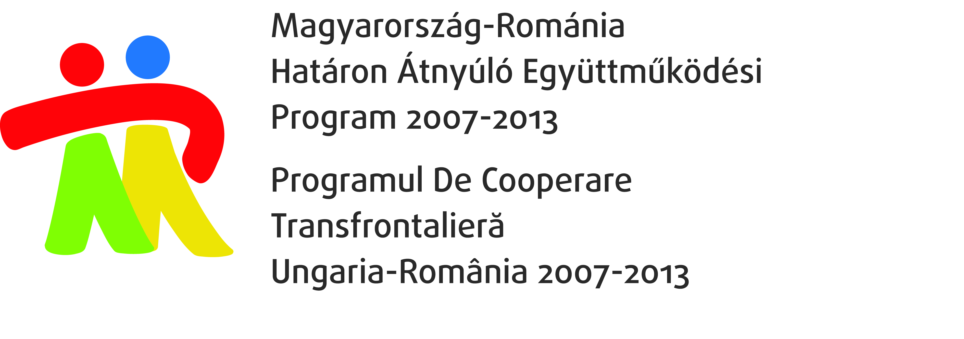

Application Form

to the opening conference of the project

„Hungarian – Romanian integrative cooperation on the labour market in the borderline region” (HUROJOB)
HURO/0801/051

I. Date and Place of the conference
30th June 2010
Kölcsey Conference Centre Hunyadi str. 1-3. Debrecen

II. Data of the applicant:
Name:
Phone number:
E-mail address /Fax number
Name of the organization:
Address of the organization: | Postal code:
Address of the organization: | Town:
Address of the organization: | Street and number:

III.Parking
I need a parking place | Yes No

IV. Please indicate if you have you wish a special menu for lunch (e.g if you are a vegetarian or have diabetes, etc) in order to fulfill your requirements as well.
Special menu reguirement

The participation at the conference is free of charge, however, registration is required. Please fill out the attached application form and send it by fax to ++36/52/513-056 or by e-mail to felda@lab.hu till 25th June 2010.

